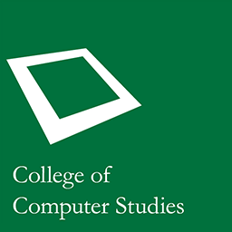

FILIET: An Information Extraction System

For Filipino Disaster-Related Tweets

**(DEPARTMENT/COLLEGE COPY)**

AY 2014-2015, Term 3

DELA CRUZ, Kyle Mc Hale B.

GARCIA, John Paul F.

KALAW, Kristine Ma. Dominique F.

LU, Vilson E.

Mr. Ralph Vincent J. Regalado

Thesis Adviser